

A few steps to the book (Instruction)
Step 1. The first entry to the system
On the website of ELS IPRbooks www.iprbookshop.ru in the upper right corner click the Entry. Enter the login and password previously received in the library.
If you have an ELS connection to an IP address, you can immediately go to step 2 (if this type of connection exists, you will see instead of a button Entry, a button Personal Account, when you click on which you can register).
Step 2. Personal Registration
Pass the personal registration:
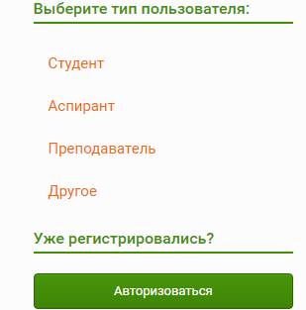
Your personal login and password will be displayed in the opened window on the screen and sent to the e-mail address, which you specified. Under this data, you will be able to work in ELS for the entire duration of your organization's subscription.
After the authorization you will be taken to the catalog of ELS IPRbooks.
Step 3. Intuitive search for publications
Intuitive search is the easiest search for editions in ELS. Enter your request (1) and select the catalog in which the edition was found (2, 3).
Example of request "History of Painting."
Search is carried out by the coincidence of the desired phrase in the title of the publication, annotations. The found publication are lined up in a relevant list (from the greatest coincidence of the phrase to the smallest results that satisfy the request).
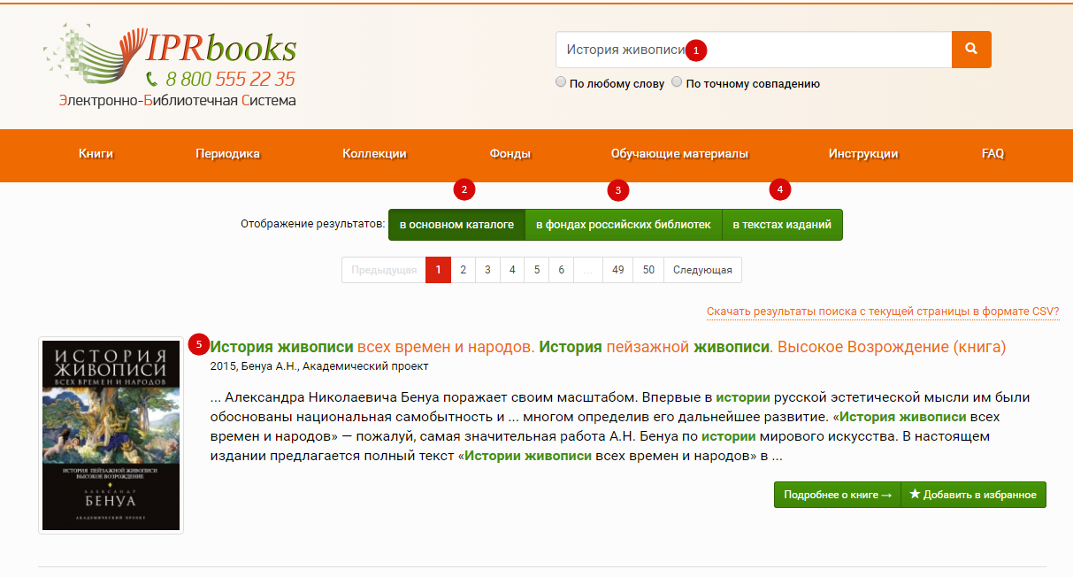
Step 4. Working with ELS catalogs
In ELS there are 4 catalogs of publications: books, periodicals, funds of Russian libraries, teaching materials: catalogs of e-courses, on-line tests, audio editions.
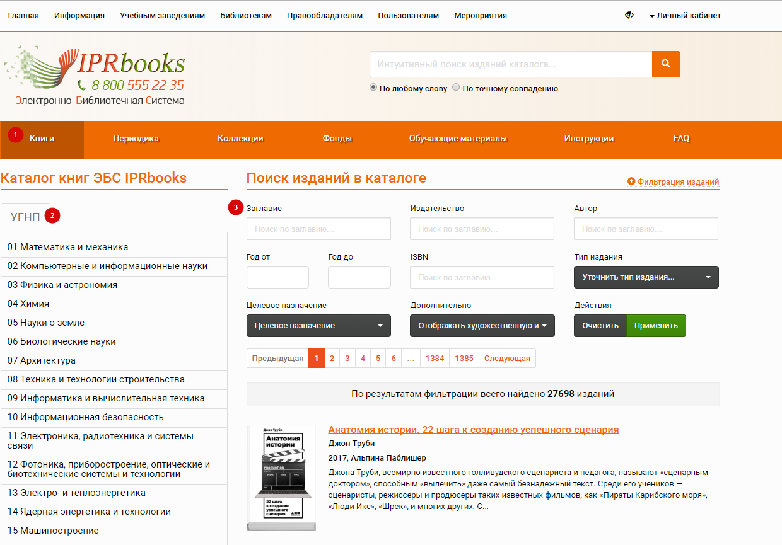
Step 5. Working with books is carried out through the personal cabinet.
Choose a book, click on the button "Read" — a window with special software for working with the publication will open. For using this software, it may be necessary to install one-time installation of the current version of Adobe Flash Player for your browser (http://get.adobe.com/ru/flashplayer).

Text selection (1)
This function is necessary for coping, note-taking, selecting and strike-through. By default, the number of symbols that can be selected at a time is 1000.
Printing of several pages of the publication (2)
The "Print" option is limited to 20 percent of the total number of pages of each available edition for each personal account. If you do not pass registration, this function is not available.
Navigation on the content (3)
In the software window for reading publications you can use the option of viewing the table of contents. If this data for contents is in processing, the button will be locked.
Note-taking the selected text (4)
On the selected text, right-click and click "Note" or the _____ icon.
Bookmarks on your favorite pages (5)
When working with publications, the user is given the opportunity to add an interesting page to the list of bookmarks.
Search in text (6)
Search of selected text in SPS Garant (7)
Selecting the text on the pages of the publication, you can click on the button with the icon (7) to get the result of the search request in the on-line version of SPS Garant.
Color highlighting the text of the publication (8)
Strike-through (9)
Navigating through the pages of the publication (10)
Correction (11)
In cases where the publisher applies an additional encoding for text protection, it may be that the letters in the summary field are not displayed correctly. In order to give the text a normal form, use this function.
Scaling (12)
Full screen view (13)

!!! All publications in the system are presented in vector format, which allows to increase the text scale to 300% without loss of quality. This function is great for users with poor eyesight.

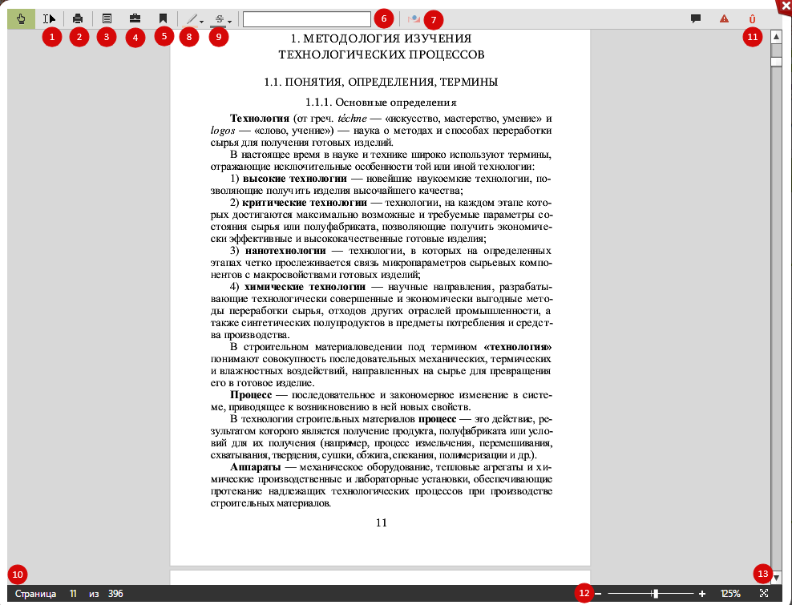
We wish you successful work in the system!

